### Semester Two Examination, 2017

### Question/Answer booklet

# MATHEMATICS

**SPECIALIST**

**UNITS 1 AND 2**

## Section Two:

## Calculator-assumed

Name

Teacher’s name

## Time allowed for this section

Reading time before commencing work: ten minutes

Working time: one hundred minutes

## Materials required/recommended for this section

***To be provided by the supervisor***

This Question/Answer booklet

Formula sheet (retained from Section One)

***To be provided by the candidate***

Standard items: pens (blue/black preferred), pencils (including coloured), sharpener, correction fluid/tape, eraser, ruler, highlighters

Special items: drawing instruments, templates, notes on two unfolded sheets of A4 paper, and up to three calculators approved for use in this examination

## Important note to candidates

No other items may be taken into the examination room. It is **your** responsibility to ensure that you do not have any unauthorised material. If you have any unauthorised material with you, hand it to the supervisor **before** reading any further.

## Structure of this paper

|  |  |  |  |  |  |
| --- | --- | --- | --- | --- | --- |
| Section | Number of questions available | Number of questions to be answered | Working  time (minutes) | Marks available | Percentage of examination |
| Section One:  Calculator-free | 8 | 8 | 50 | 48 | 35 |
| Section Two:  Calculator-assumed | 13 | 13 | 100 | 95 | 65 |
|  | | |  | **Total** | 100 |

|  |  |  |
| --- | --- | --- |
| Markers use only | | |
| Question | Maximum | Mark |
| 9 | 6 |  |
| 10 | 6 |  |
| 11 | 6 |  |
| 12 | 9 |  |
| 13 | 8 |  |
| 14 | 6 |  |
| 15 | 7 |  |
| 16 | 10 |  |
| 17 | 7 |  |
| 18 | 9 |  |
| 19 | 10 |  |
| 20 | 8 |  |
| 21 | 6 |  |
| S2 Total | 95 |  |
| S2 Wt (×0.6633) | 65% |  |

## Instructions to candidates

1. The rules for the conduct of examinations are detailed in the school handbook. Sitting this examination implies that you agree to abide by these rules.

2. Write your answers in this Question/Answer booklet.

3. You must be careful to confine your response to the specific question asked and to follow any instructions that are specified to a particular question.

4. Additional working space pages at the end of this Question/Answer booklet are for planning or continuing an answer. If you use these pages, indicate at the original answer, the page number it is planned/continued on and write the question number being planned/continued on the additional working space page.

5. Show all your working clearly. Your working should be in sufficient detail to allow your answers to be checked readily and for marks to be awarded for reasoning. Incorrect answers given without supporting reasoning cannot be allocated any marks. For any question or part question worth more than two marks, valid working or justification is required to receive full marks. If you repeat any question, ensure that you cancel the answer you do not wish to have marked.

6. It is recommended that you do not use pencil, except in diagrams.

7. The Formula sheet is not to be handed in with your Question/Answer booklet.

Section Two: Calculator-assumed 65% (95 Marks)

This section has**thirteen (****13)** questions. Answer **all** questions. Write your answers in the spaces provided.

Working time: 100 minutes.

Question 9 (6 marks)

An exam has two parts, $I$ and $II$, containing 15 and 8 questions respectively.

Determine the number of different combinations of questions a candidate could choose if they must answer

(a) 5 questions from part $I$ and 4 questions from part $II$. (2 marks)

(b) 3 questions, all chosen from the same part. (2 marks)

(c) 3 questions, with at least one question from each part. (2 marks)

Question 10 (6 marks)

(a) The point $P(21, -11)$ is translated(added) by the column vectors $\left[\begin{matrix}x \\ y\end{matrix}\right]$ and $\left[\begin{matrix}-7 \\ 13\end{matrix}\right]$ to $P'(-6, 5)$. Determine the values of the constants $x$ and $y$. (2 marks)

(b) Determine the single matrix that represents, in order, the composition of a reflection in the line $y=-x$ followed by an anti-clockwise rotation of $135°$ about the origin. Express matrix coefficients in exact form. (4 marks)

Question 11 (6 marks)

(a) A circle property says that if chords of a circle are of equal length then they subtend equal angles at the centre.

(i) Write the converse of this statement. (1 mark)

(ii) Draw a diagram to illustrate the converse statement and state whether the converse is also true. (2 marks)

(b) The diagram below shows four points $A$, $B$, $C$ and $D$ lying on the circumference of a circle. The line $PQ$ is a tangent to the circle at $A$, $∠BDC=21°$, $∠PAD=35°$ and $∠QAB=62°$.

Determine the size of angles $x$, $y$ and $z$. (3 marks)

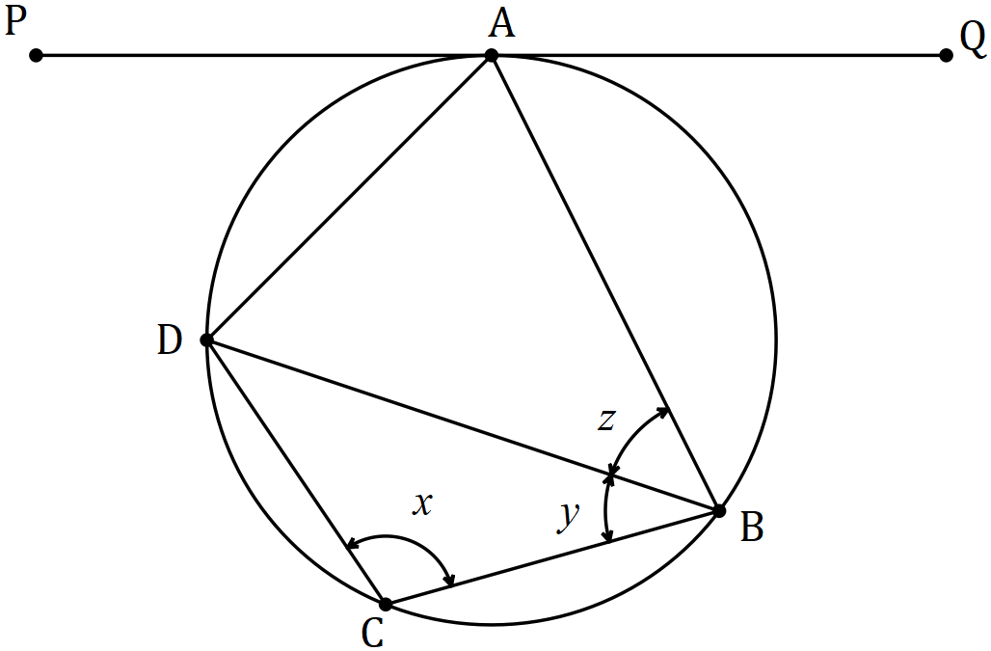

Question 12 (9 marks)

(a) If $p=4i-2j$ and $q=3i+2j$ determine

(i) the angle between the directions of $p$ and $q$, to the nearest tenth of a degree.

(2 marks)

(ii) the scalar projection of $q$ on $p$. (2 marks)

(b) The vector $21i+5aj$ has a magnitude of $29$ and is perpendicular to the vector $4i-2bj$. Determine the values of the constants a and b, where $a<b$. (5 marks)

Question 13 (8 marks)

In the diagram below, forces $F_{1}$ and $F_{2}$ act on a body at the origin.

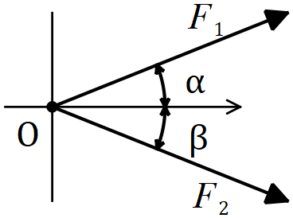

(a) If $F_{1}=50 N$, $F_{2}=65 N$, $α=22°$ and $β=32°$, determine the magnitude of the resultant force and the angle it makes with the positive $x$ axis. (5 marks)

(b) If $F_{1}=75 N$ and $F_{2}=95 N$, determine the angles $α$ and $β$ so that the resultant force is directed along the positive $x$ axis and has a magnitude of $155 N$. (3 marks)

Question 14 (6 marks)

(a) Prove that $\tan{3A}=\begin{matrix}3\tan{A}-\tan^{3}{A} \\ \overline{ 1-3\tan^{2}{A }} \end{matrix}$. (4 marks)

(b) Hence, or otherwise, solve $3\tan{A}-\tan^{3}{A}=1-3\tan^{2}{A}, 0≤A≤\frac{π}{6}$. (2 marks)

Question 15 (7 marks)

(a) The diagram below shows vertices $A$, $B$ and $C$ of rhombus $OABC$ lying on the circumference of circle centre $O$ and point $M$ lying on the major arc $AC$. Determine the size of angle $AMC$. (3 marks)

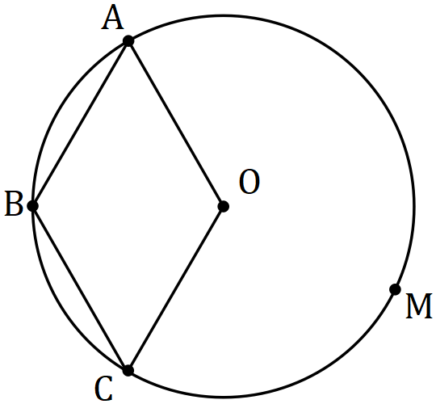

(b) Use a vector method to prove that the diagonals of a rhombus are perpendicular.

(4 marks)

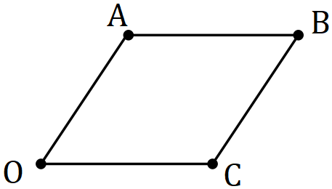

Let $\vec{OC}=c$ and $\vec{OA}=a$.

Question 16 (10 marks)

(a) The graph of $y=\cos\left(a\left(x+b\right)\right)+c$ is shown below for $0≤x≤2π$.

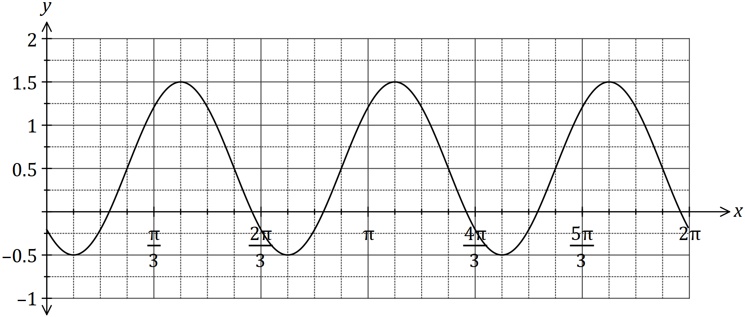

Determine the value of the positive constants $a$, $b$ and $c$. (3 marks)

(b) On the axes below, sketch the graph of $y=2\operatorname{cosec}{(x-π)}$, $0≤x≤2π$. (3 marks)

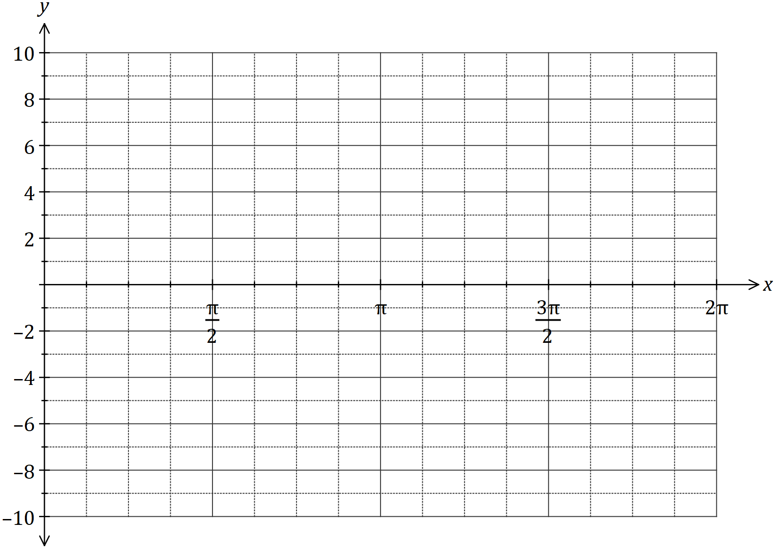

(c) The displacement, $x$ cm, of a particle from a fixed point $O$ varies with time, $t$ seconds, according to the model $x=4\sin{(3πt)}-7\cos\left(3πt\right), t≥0$. Determine

(i) the initial displacement of the particle from $O$. (1 mark)

(ii) the exact amplitude of the motion. (1 mark)

(iii) the period of motion. (1 mark)

(iv) the first time that the particle passes through $O$, rounded to two decimal places.

(1 mark)

Question 17 (4 marks)

A number is formed using five different digits chosen from those in the number 681 429. Determine how many different numbers can be formed that are

(i) odd. (1 mark)

(ii) greater than 90 000. (1 mark)

(iii) odd or greater than 90 000. (2 marks)

Question 18 (9 marks)

Triangle $ABC$ has vertices $A\left(1, -2\right)$, $B\left(5, 2\right)$ and $C\left(4, -4\right)$.

(a) The vertices $ABC$ are transformed to $A^{'}B^{'}C^{'}$ using matrix $\left[\begin{matrix}1 & 0 \\ 0 & -1\end{matrix}\right]$. Write down the new coordinates of the vertices and describe the transformation. (4 marks)

(b) The vertices $ABC$ are transformed to $A^{''}B''C''$ by matrix $M$ so that the new coordinates of the vertices are $A''\left(-6, -4\right)$, $B''\left(6, -20\right)$ and $C''\left(-12, -16\right)$.

(i) Determine the transformation matrix $M$. (3 marks)

(ii) If the area of triangle $ABC$ is $k$ square units, express the area of triangle $A''B''C''$ in terms of $k$. (2 marks)

Question 19 (10 marks)

(a) Trapezium $OPQR$ has parallel sides $PQ$ and $OR$. $M$ is the midpoint of $OQ$ and $N$ lies on $QR$ so that $RN:NQ=1:2$.

Given that $\vec{OP}=p$, $\vec{OR}=r$ and $\vec{PQ}=2r$, determine the following in terms of $p$ and $r$.

(i) $\vec{OM}$. (2 marks)

(ii) $\vec{ON}$. (2 marks)

(iii) $\vec{NM}$. (2 marks)

(b) Quadrilateral $OABC$ is shown below, where $P$, $Q$, $R$ and $S$ are the midpoints of the sides $OA$, $AB$, $BC$ and $OC$ respectively. Let $\vec{OP}=a$, $\vec{AQ}=b$ and $\vec{OS}=c$.

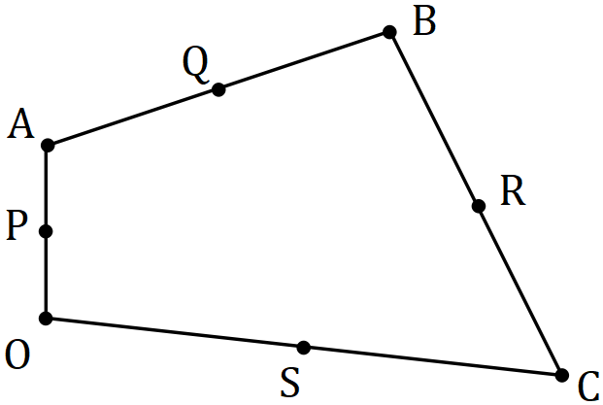

Show that $\vec{PS}=\vec{QR}$. (4 marks)

Question 20 (8 marks)

The sum of the first $n$ terms of the sequence $1+5+9+13+…+(4n-3)$ is $n(2n-1)$.

(a) Show that this statement is true when $n=6$. (2 marks)

(b) Use mathematical induction to prove the statement is true for $n∈Z ,n≥6$. (6 marks)

Question 21 (6 marks)

The diagram shows a semi-circle, with diameter $SR$ and centre $O$, circumscribed by triangle $ABC$, in which $∠BAC=48°$ and $∠BCA=36°$.

Determine, with reasons, the size of angles $∠PRO$ and $∠PQR$.

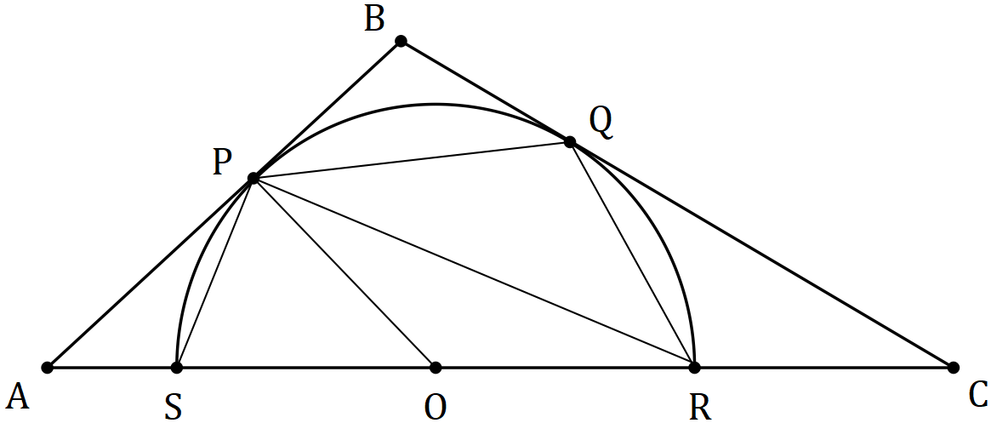

Additional working space

Question number: _________

Additional working space

Question number: _________